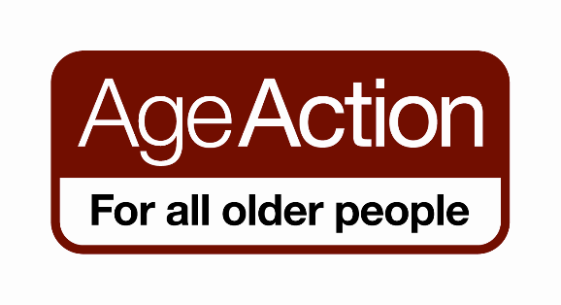

## 

## Volunteer Role Description (Repair Person)

**Position title:** Volunteer Care & Repair

**Location: Cobh**

**Purpose of Position**

To Carry out small repairs and complete minor home tasks for older people who are clients of the Care & Repair Service.

**Main Job tasks & Responsibilities**

Communicating with older people, administrator and other volunteers

Assessment of jobs allocated

Minor gardening (e.g. mowing lawns)

Minor home decorating (e.g. interior painting)

Tacking down carpets

Changing plugs, fuses and light bulbs

Installing security locks and chains;

Hanging curtains

Installing domestic smoke alarms

Other small home repairs

Volunteers will be expected to work in accordance with the policies, procedures and ethos of the Care & Repair Programme

**Required Experience/Skills/Qualifications**

Friendly caring approach; good phone manner

Good handyman/repair/DIY/household skills

Good organisational skills

**Commitment expected**

Approximately two hours per week, i.e. one job to be completed per week

**Training**

Training & Induction provided by Age Action Ireland and the local Care and Repair group.